Stewardship Moment
In Acts 11:1-18 the apostle Peter has been fasting and is pretty hungry, but when God sends him a dream, he sees anything but his own comfort food! He sees the food that other people liked to eat. Peter did not want a change in recipes from what he was used to. But he quickly came to understand that a dynamic, growing church was open to people with different customs, dress, and eating habits. Part of our offering to Christ and to each other is the acceptance of other comforts - ways of living - that help us to accept and love each other in the name of God.


Children and Their Safety are Important at Chestnut Hill UMC
We rejoice that as a church we are able to offer carefully planned, age appropriate care and activities for our children and youth.
Today, children ages 6 and above will stay in the sanctuary for worship.
The Nursery for infants up to age 6 is located in Classroom 101 (exit through the right side door at the front of the sanctuary, pass through “the Commons,” go through the double doors to the Education Building and follow the hallway to the
Nursery at the end of the hall on the left).

DIRECTORY OF CHESTNUT HILL UNITED METHODIST CHURCH
 | Sharma Lewis | Richmond Area Resident Bishop
 | Peter D. Weaver | Interim Bishop
 | Scott Davis | Lynchburg District Superintendent
 | Liz Ecklund | Minister
 | Vernie Barrow | Minister Emeritus
 | Monica Campbell | Administrative Assistant
 | Heather Wilson | Director of Music Ministry
 | Judy Martin | Bookkeeper
 | Judy Robertson | Lay Leader
 | Erin Ecklund | Nursery Supervisor


Chestnut Hill
United Methodist Church

Making disciples of Jesus Christ
for the transformation of the world.
You are welcome at Chestnut Hill UMC.

4660 Fort Avenue ~ Lynchburg, Virginia 24502
Church: 434-239-8423
Pastor’s Cell: 434-258-2934; Pastor’s Home: 434-319-5646
Email Pastor Liz: Pastorliz@aol.com
chestnuthillumc@comcast.net ~ on the web at chestnuthillumc.net
Find us on Facebook: Chestnut Hill United Methodist Church

Chestnut Hill United Methodist Church
10:30 a.m. ~ May 19, 2019 ~ Fifth Sunday of Easter
Our ministry vision for the Virginia Annual Conference is “to be disciples of Jesus Christ who are lifelong learners, who influence others to serve.”
Welcome! Join us in worshiping God!
Welcome and Ministry Announcements
Welcome in the name of Christ our Lord. Please register your attendance,
printing your name, address, phone, and email, when the pew pad is passed to you.
Thank you for silencing cell phones as we gather to worship God.
Invocation
Prelude “Prelude on Promise Land” arr. Giamanco
*Call to Worship
The power of the Lord is with us this day; let us be glad in it!
For God has touched our hearts that we might know life itself.
Almighty God created the universe and all that is within it,
Yet God knows every one of us, even the thoughts of our hearts.
And even though we fall short of God's will for us, God loves us.
Blessed be the name of the Lord!
*Singing Our Faith # 68 “When in Our Music God Is Glorified”
Morning Prayer
O Christ, our wonderful Lord and Savior, You came to teach us what it means to love as You do and to call us to love one another as You first loved us. We praise You, O Lord. In Christ we pray. Amen.
Choral Anthem “Spin the Wheel Toward Heaven” arr. Choplin
Prayer for Illumination Heather Wilson
Let the words of our mouths, and the meditations of our hearts be acceptable in your sight, O Lord, our Rock and our Redeemer. Amen.

New Testament Lesson Acts 11:1-18 (CEB) Heather Wilson
Gospel Lesson John 13:31-35 (MSG) Heather Wilson
The Word of God for the people of God.
Thanks be to God.
*Singing Our Faith # 2223 “They’ll Know We Are Christians by Our Love”
The Good News “Family”
The Giving of God’s Tithes and Our Gifts
Prayer of Thanksgiving
Offertory “Great Is Thy Faithfulness” arr. Berry
*Doxology # 95 Praise God from whom all blessings flow; praise him, all
Creatures here below; praise him above, ye heavenly host; praise Father, Son, and Holy Ghost. Amen.
The Prayers of the People
The Lord’s Prayer
Our Father, who art in heaven, hallowed be thy name. Thy kingdom come,
Thy will be done on earth as it is in heaven. Give us this day our daily bread and forgive us our trespasses, as we forgive those who trespass against us. And lead us not into temptation, but deliver us from evil. For thine is the kingdom, and the power, and the glory, forever. Amen.
*Singing Our Faith # 2008 “Let All Things Now Living”
*Blessing and Dismissal
*Postlude
Scatter to Serve God & Neighbor
Welcome to all! We gather to praise God for the innumerable blessings given to us and to grow deeper in the Spirit. Joyfully, let us lift our hearts to God.

**This Week’s Calendar**

Monday, 5/20 | 9:30 a.m. | “Reckless Love” Bible Study
Tuesday, 5/21 | 9:00 a.m. | Prayer Group
Wednesday, 5/22 | 11:00 a.m. | Top of the Hill  Rev. Liz Ecklund will be guest speaker. She will give her insight on one of the books she has read from Top of the Hill’s reading program.  Bring a sandwich. Dessert and drinks provided.
Thursday, 5/23 | 6:45 p.m. | Choir
** Looking Ahead on the Calendar **
Monday, 5/27 |  | Memorial Day ~ Church Office Closed
GRADUATE INFORMATION NEEDED
Chestnut Hill UMC would like to honor its graduates. If you (or your child or grandchild) is an elementary, high school, college, or vocational school graduate this year, please call the church office (239-8423) or email us at chestnuthillumc@comcast.net and let us know what school you will be graduating from and your plans for the future.
Read Ahead
May 26, 2019~Memorial Day Sunday ~The Scriptures are Acts 16:9-15, Revelation 21:1-10, 22-22:5 & Psalm 67. The sermon text is John 14:23-29 and the message is “Peace of Christ”.
In the Grocery Cart This Month
For MAY: “Toothpaste, Maxi Pads & Tampons, Paper Towels, Laundry Detergent, and Cleaning Products”. This will assist people through Park View Community Mission. Place donations in the grocery cart, located in the Commons.

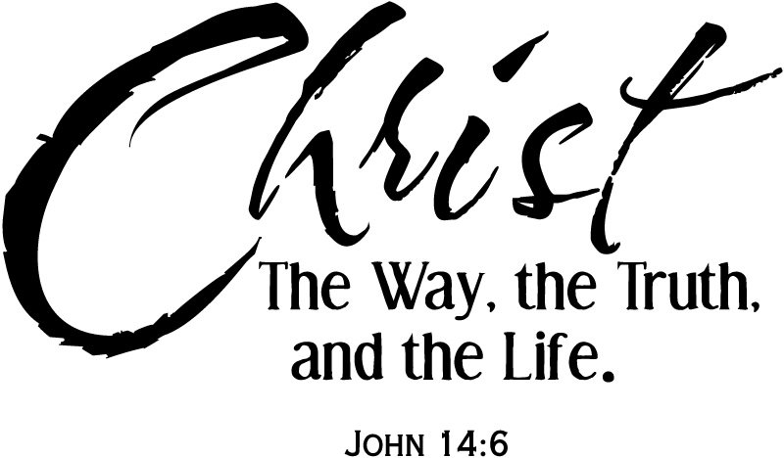

**This Week’s Calendar**

Monday, 5/20 | 9:30 a.m. | “Reckless Love” Bible Study
Tuesday, 5/21 | 9:00 a.m. | Prayer Group
Wednesday, 5/22 | 11:00 a.m. | Top of the Hill  Rev. Liz Ecklund will be guest speaker. She will give her insight on one of the books she has read from Top of the Hill’s reading program.  Bring a sandwich. Dessert and drinks provided.
Thursday, 5/23 | 6:45 p.m. | Choir
** Looking Ahead on the Calendar **
Monday, 5/27 |  | Memorial Day ~ Church Office Closed
GRADUATE INFORMATION NEEDED
Chestnut Hill UMC would like to honor its graduates. If you (or your child or grandchild) is an elementary, high school, college, or vocational school graduate this year, please call the church office (239-8423) or email us at chestnuthillumc@comcast.net and let us know what school you will be graduating from and your plans for the future.
Read Ahead
May 26, 2019~Memorial Day Sunday ~The Scriptures are Acts 16:9-15, Revelation 21:1-10, 22-22:5 & Psalm 67. The sermon text is John 14:23-29 and the message is “Peace of Christ”.
In the Grocery Cart This Month
For MAY: “Toothpaste, Maxi Pads & Tampons, Paper Towels, Laundry Detergent, and Cleaning Products”. This will assist people through Park View Community Mission. Place donations in the grocery cart, located in the Commons.

